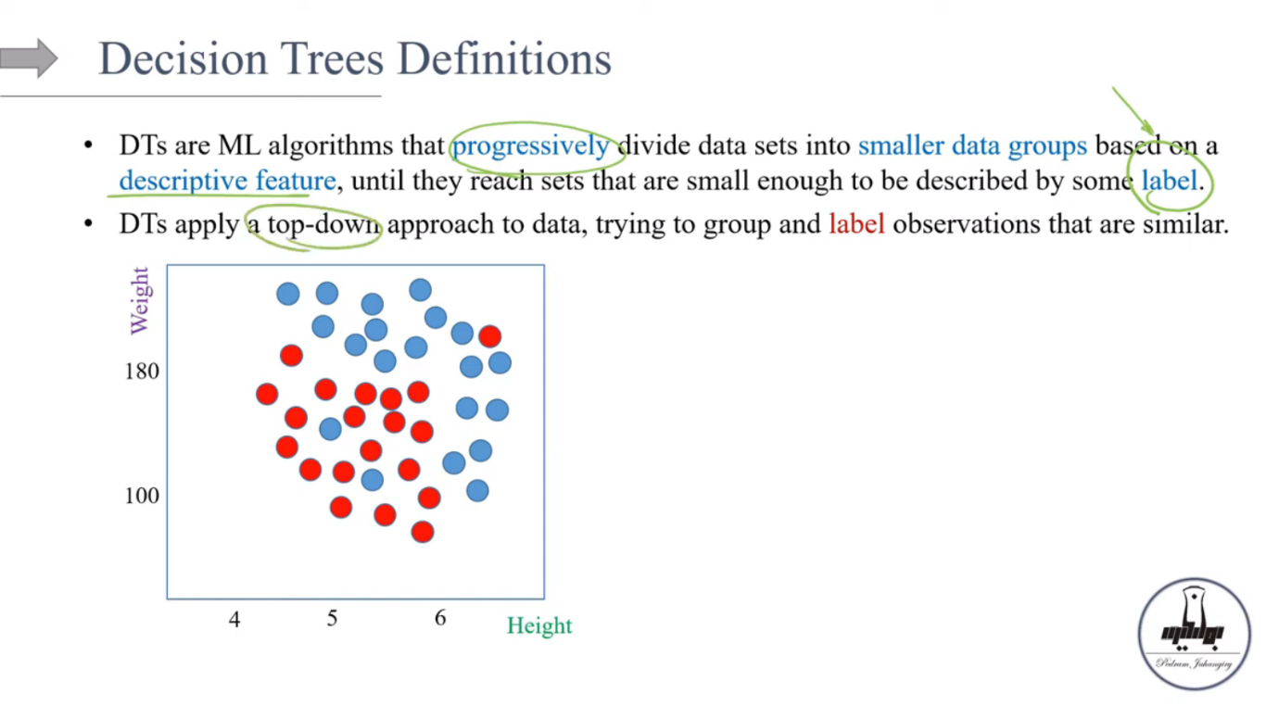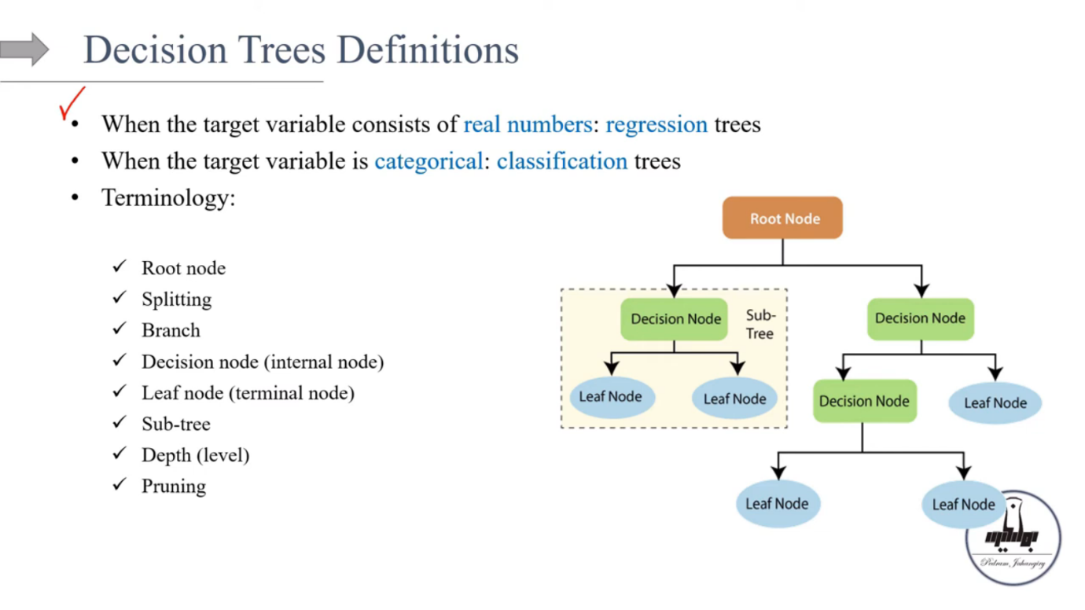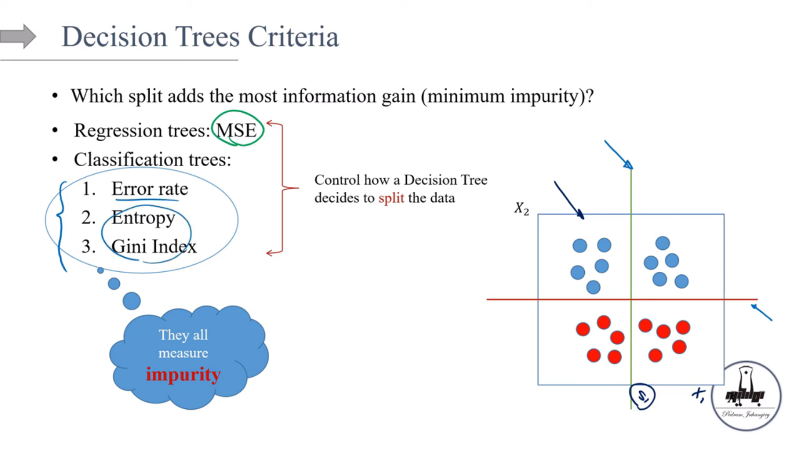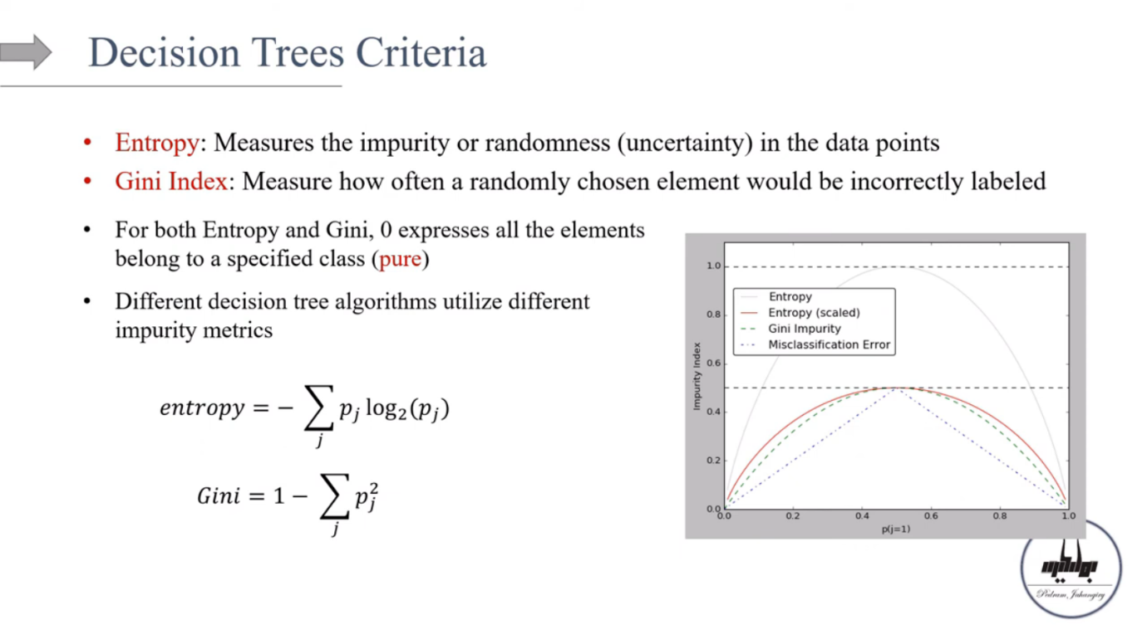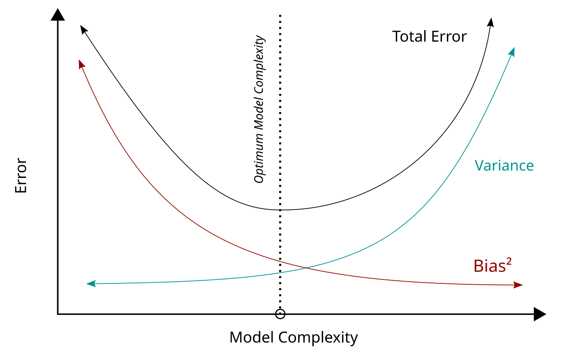

**Interview Answer:**

Decision trees are supervised machine learning algorithms that recursively partition the dataset into subsets based on feature values. The algorithm uses a top-down approach, selecting the feature that provides the most information gain or minimizes impurity (using metrics like Gini impurity or entropy) at each node. The goal is to create leaf nodes that contain data points belonging to a single class (in classification) or have similar target values (in regression)."

